**Project Report**

**VISUALIZING AND PREDICTING HEART DISEASE WITH AN INTERACTIVE DASHBOARD**

**By:**

**Soniga N**

**Sneha A R**

**Swathika T**

**Sanjuvikashini A P**

**INDEX**

1. **INTRODUCTION** 
   1. Project Overview
   2. Purpose
2. **LITERATURE SURVEY**
   1. Existing problem
   2. References
   3. Problem Statement Definition
3. **IDEATION & PROPOSED SOLUTION**
   1. Empathy Map Canvas
   2. Ideation & Brainstorming
   3. Proposed Solution
   4. Problem Solution fit
4. **REQUIREMENT ANALYSIS**
   1. Functional requirement
   2. Non-Functional requirements
5. **PROJECT DESIGN**
   1. Data Flow Diagrams
   2. Solution & Technical Architecture
   3. User Stories
6. **PROJECT PLANNING & SCHEDULING**
   1. Sprint Planning & Estimation
   2. Sprint Delivery Schedule
   3. Reports from JIRA
7. **CODING & SOLUTIONING (Explain the features added in the project along with code)**
   1. Feature 1
   2. Feature 2
   3. Database Schema (if Applicable)
8. **TESTING** 
   1. Test Cases
   2. User Acceptance Testing
9. **RESULTS**
   1. Performance Metrics
10. **ADVANTAGES & DISADVANTAGES**
11. **CONCLUSION**
12. **FUTURE SCOPE**
13. **APPENDIX**

**Introduction:**

**Project Overview :**

Heart disease defines a range of conditions that affect human heart. The name "heart disease" is often used commonly with the name "cardiovascular disease". Heart disease is a term that allow to a large number of medical circumstances related to heart. These medical circumstances characterize the irregular health condition that directly affects the heart and all its parts. Heart disease generally allows to some conditions that involve narrowed or blocked blood vessels which can lead to a heart attack, stroke or chest pain. Other heart conditions, such as those that affect your heart's muscle, valves or rhythm, also are considered forms of heart disease .There are various types of cardiovascular disease. The most similar types are heart failure (HF) and Coronary Artery Disease (CAD). The main root cause of heart failure (HF) is occur due to the blockade or narrowing down of coronary arteries. Coronary arteries also supply blood to the heart. Data mining is a non trivial extraction of implicit, previously unknown potential useful information called as knowledge from the medical data using complex algorithms. Big data (BD) can be referred as huge record of information set. Big Data and Data Mining are two various things. The task carried out by these two methods are similar focusing on collecting the huge amount of data, handling them and preparing report on the data by taking out the information which is knowledgeable. Data Mining is basically an activity of observing the patterns in the data which is relevant and with particular information by using Big Data. The useful patterns with hidden patterns, unknown correlations are analytically handled for making knowledgeable decision through this Big Data analytics process.

**Purpose :**

The health care industries collect huge amounts of data that contain some hidden information, which is useful for making effective decisions. For providing appropriate results and making effective decisions on data, some advanced data mining techniques are used. In this study, an effective heart disease prediction system (EHDPS) is developed using neural network for predicting the risk level of heart disease. The system uses 15 medical parameters such as age, sex, blood pressure, cholesterol, and obesity for prediction. The EHDPS predicts the likelihood of patients getting heart disease. It enables significant knowledge, eg, relationships between medical factors related to heart disease and patterns, to be established. We have employed the multilayer perceptron neural network with backpropagation as the training algorithm. The obtained results have illustrated that the designed diagnostic system can effectively predict the risk level of heart diseases.

**Literature Survey:**

**Existing Problem:**

[1]. Aakash Chauhan et al. (2018) presented “Heart Disease Prediction using Evolutionary Rule Learning”. This study eliminates the manual task that additionally helps in extracting the information (data) directly from the electronic records. To generate strong association rules, we have applied frequent pattern growth association mining on patient’s dataset. This will facilitate (help) in decreasing the amount of services and shown that overwhelming majority of the rules helps within the best prediction of coronary sickness

[2]. Ashir Javeed, Shijie Zhou et al. (2017) designed “An Intelligent Learning System based on Random Search Algorithm and Optimized Random Forest Model for Improved Heart Disease Detection”. This paper uses random search algorithm (RSA) for factor selection and random forest model for diagnosing the cardiovascular disease. This model is principally optimized for using grid search algorithmic program. Two forms of experiments are used for cardiovascular disease prediction. In the first form, only random forest model is developed and within the second experiment the proposed Random Search Algorithm based random forest model is developed. This methodology is efficient and less complex than conventional random forest model. Comparing to conventional random forest it produces 3.3% higher accuracy. The proposed learning system can help the physicians to improve the quality of heart failure detection.

[3].“Effective Heart Disease Prediction Using Hybrid Machine Learning Techniques” proposed by Senthilkumar Mohan, Chandrasegar Thirumalai et al. (2019) was efficient technique using hybrid machine learning methodology. The hybrid approach is combination of random forest and linear method. The dataset and subsets of attributes were collected for prediction. The subset of some attributes were chosen from the pre-processed knowledge(data) set of cardiovascular disease .After prep-processing , the hybrid techniques were applied and disgnosis the cardiovascular disease

[4]. K.Prasanna Lakshmi, Dr. C.R.K.Reddy (2015) designed “Fast Rule-Based Heart Disease Prediction using Associative Classification Mining”. In the proposed Stream Associative Classification Heart Disease Prediction (SACHDP), we used associative classification mining over landmark window of data streams. This paper contains two phases: one is generating rules from associative classification mining and next one is pruning the rules using chi-square testing and arranging the rules in an order to form a classifier. Using these phase to predict the heart disease easily

[5]. M.Satish, et al. (2015) used different Data Mining techniques like Rule based, Decision Tree, Navie Bayes, and Artifical Neural Network. An efficient approach called pruningclassification association rule (PCAR) was used to generate association rules from cardiovascular disease warehouse for prediction of Heart Disease. Heart attack data warehouse was used for pre-processing for mining. All the above discussed data mining technique were described

[6]. Lokanath Sarangi, Mihir Narayan Mohanty, Srikanta Pattnaik (2015) “An Intelligent Decision Support System for Cardiac Disease Detection”, designed a cost efficient model by using genetic algorithm optimizer technique. The weights were optimized and fed as an input to the given network. The accuracy achieved was 90% by using the hybrid technique of GA and neural networks

[7]. “Prediction and Diagnosis of Heart Disease by Data Mining Techniques” designed by Boshra Bahrami, Mirsaeid Hosseini Shirvani. This paper uses various classification methodology for diagnosing cardiovascular disease. Classifiers like KNN, SVO classifier and Decision Tree are used to divide the datasets. Once the classification and performance evaluation the Decision tree is examined as the best one for cardiovascular disease prediction from the dataset

**References:**

[1] Aakash Chauhan , Aditya Jain , Purushottam Sharma , Vikas Deep, “Heart Disease Prediction using Evolutionary Rule Learning”, “International Conference on "Computational Intelligence and Communication Technology” (CICT 2018).

[2] Ashir Javeed, Shijie Zhou, Liao Yongjian, Iqbal Qasim, Adeeb Noor, Redhwan Nour4, Samad Wali And Abdul Basit , “An Intelligent Learning System based on Random Search Algorithm and Optimized Random Forest Model for Improved Heart Disease Detection” , IEEE Access 2017.

[3] Senthilkumar Mohan, Chandrasegar Thirumalai, and Gautam Srivastava, “Effective Heart Disease Prediction Using Hybrid Machine Learning Techniques”, IEEE Access 2019.

[4] K.Prasanna Lakshmi, Dr. C.R.K.Reddy, “Fast Rule-Based Heart Disease Prediction using Associative Classification Mining”, IEEE International Conference on Computer, Communication and Control (IC4-2015).

[5] M.Satish, D Sridhar, “Prediction of Heart Disease in Data Mining Technique”, International Journal of Computer Trends & Technology (IJCTT), 2015.

[6] Lokanath Sarangi, Mihir Narayan Mohanty, Srikanta Pattnaik, “An Intelligent Decision Support System for Cardiac Disease Detection”, IJCTA, International Press 2015.

[7] Boshra Bahrami, Mirsaeid Hosseini Shirvani, “Prediction and Diagnosis of Heart Disease by Data Mining Techniques”, Journal of Multidisciplinary Engineering Science and Technology (JMEST) ISSN: 3159-0040 Vol. 2 Issue 2, February–2015.

**Problem Statement and Definition:**

Now-a-days many people from younger age to older age are affected by heart diseases,due to some less technological solutions many people aren't able to analyze the problem and unable to find the issue and problems in the heart,thus by this method we can analyze and find the problem and proper treatment can be provided.

Who does this effect ?

The People from younger as well as older age.

What are the boundaries of the problem ?

Costlier diagnostic process and some other analyzing factors.

What is the issue?

There is no simple and instant diagnostics process for this health analysis.

When does this occur ?

People when doing activities which stresses the heart pumping process.

Why is it important that we fix the problem?

By proper analyzing and finding process the issue can be solved.

What solution to solve this issue?

Data analytics and Data Visualization methods are used for this.

What methodology used to solve the issue ?

Costlier diagnostic process and some other analyzing factors.

**Ideation & Proposed Solution:**

**Empathy Map:**

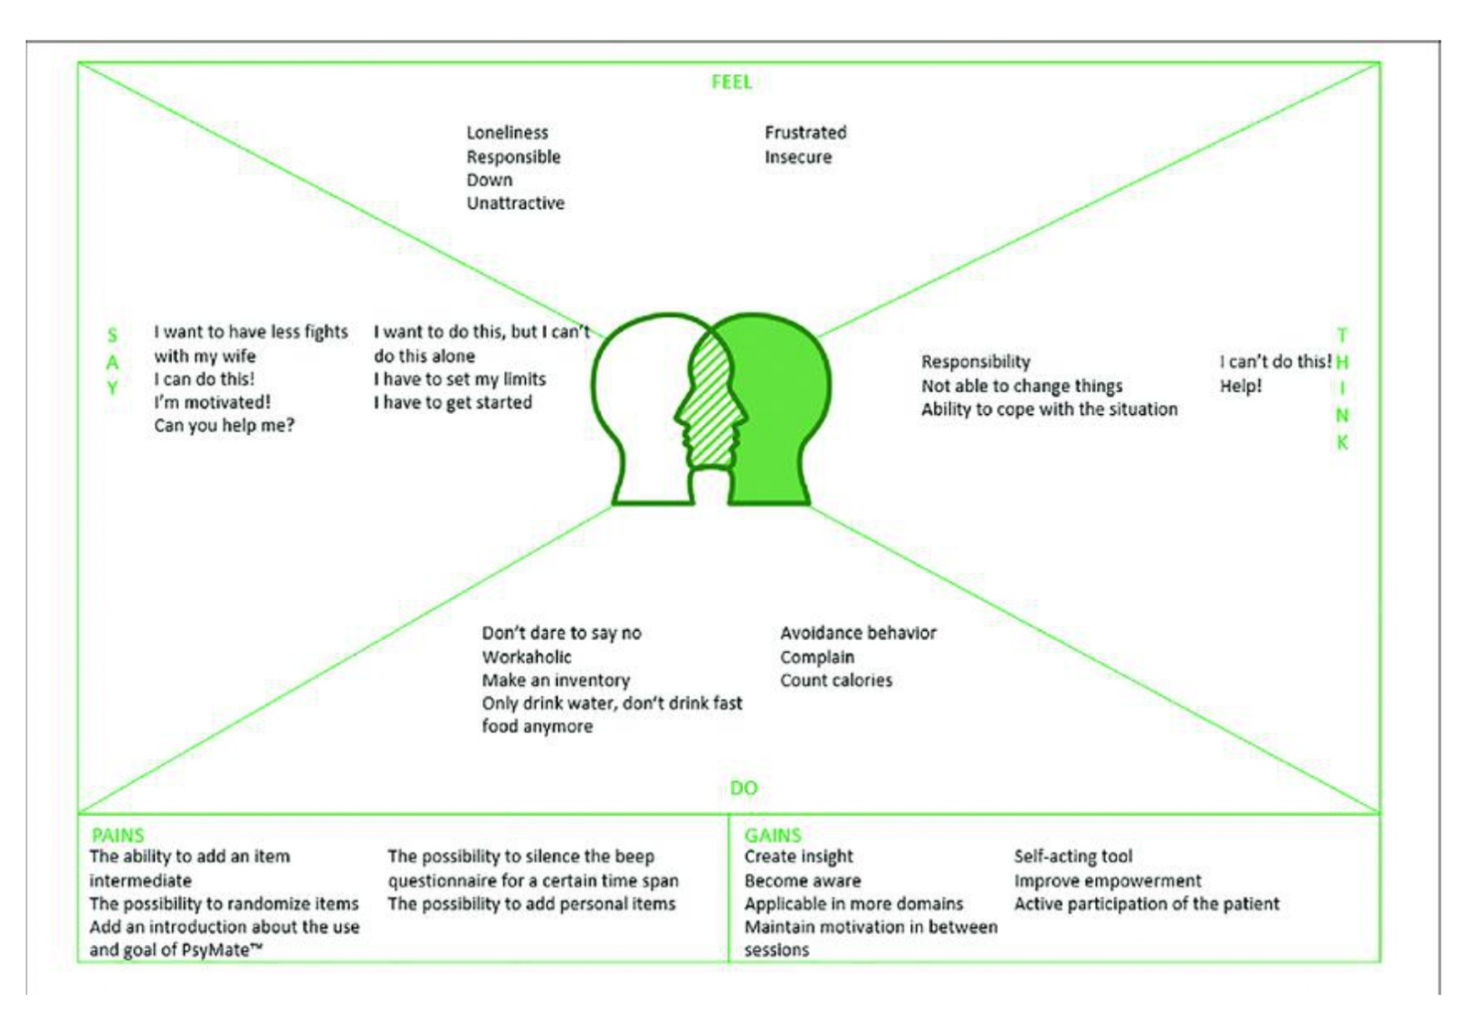

**Ideation and Brainstorming:**

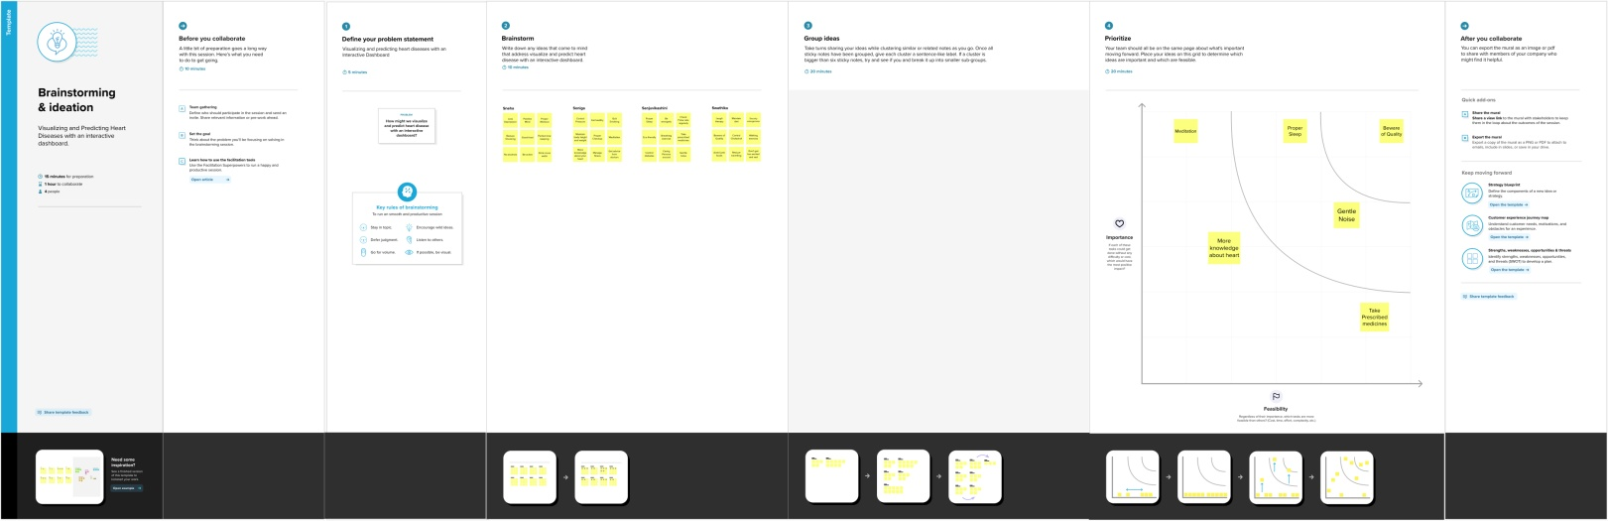

**Problem Statement :**

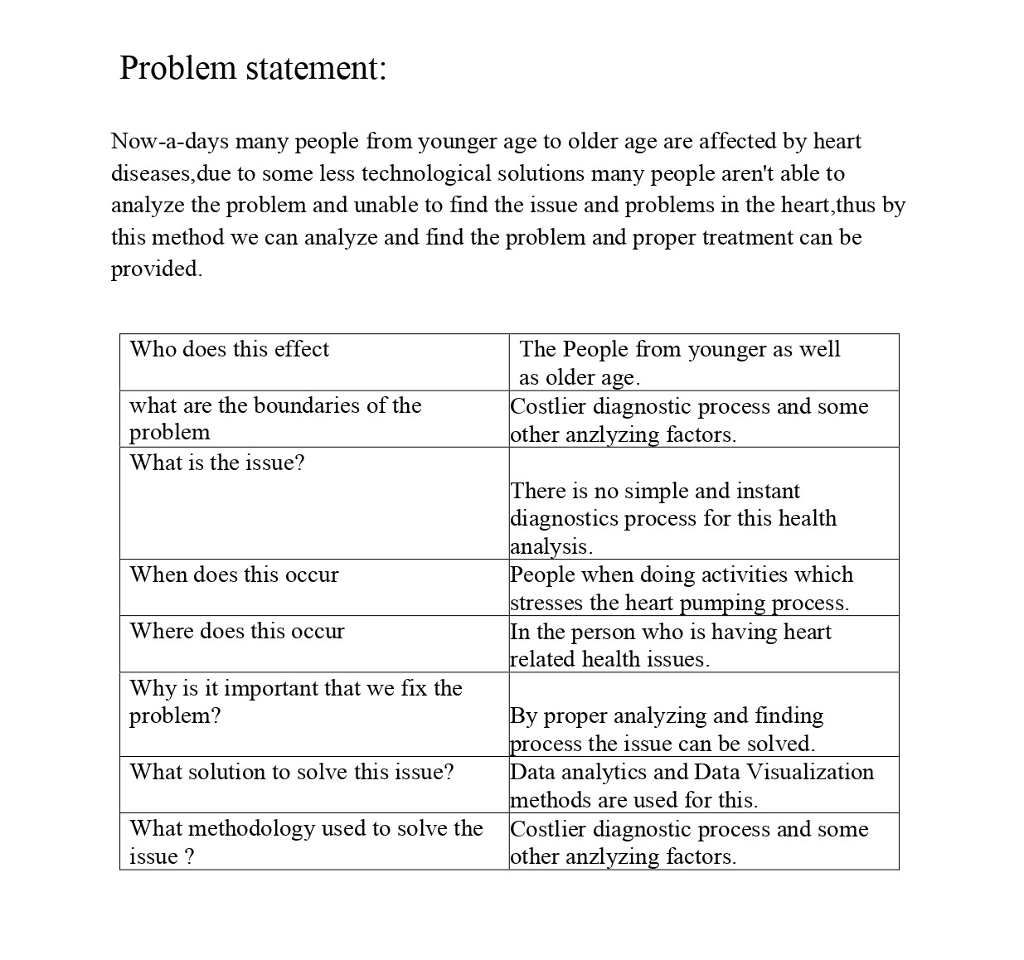

**Proposed Solution and Problem Solution Fit :**

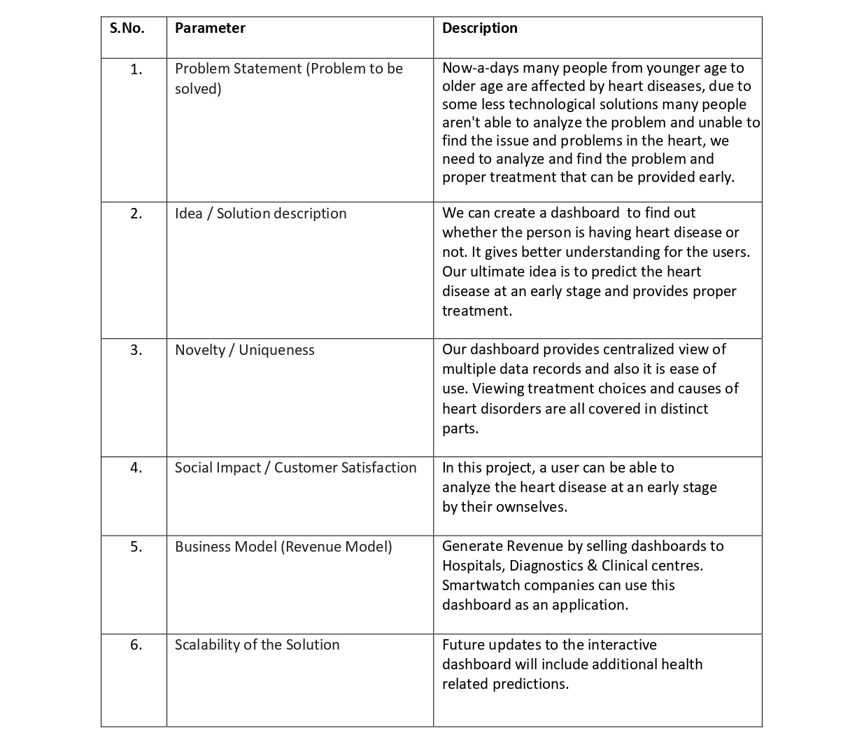

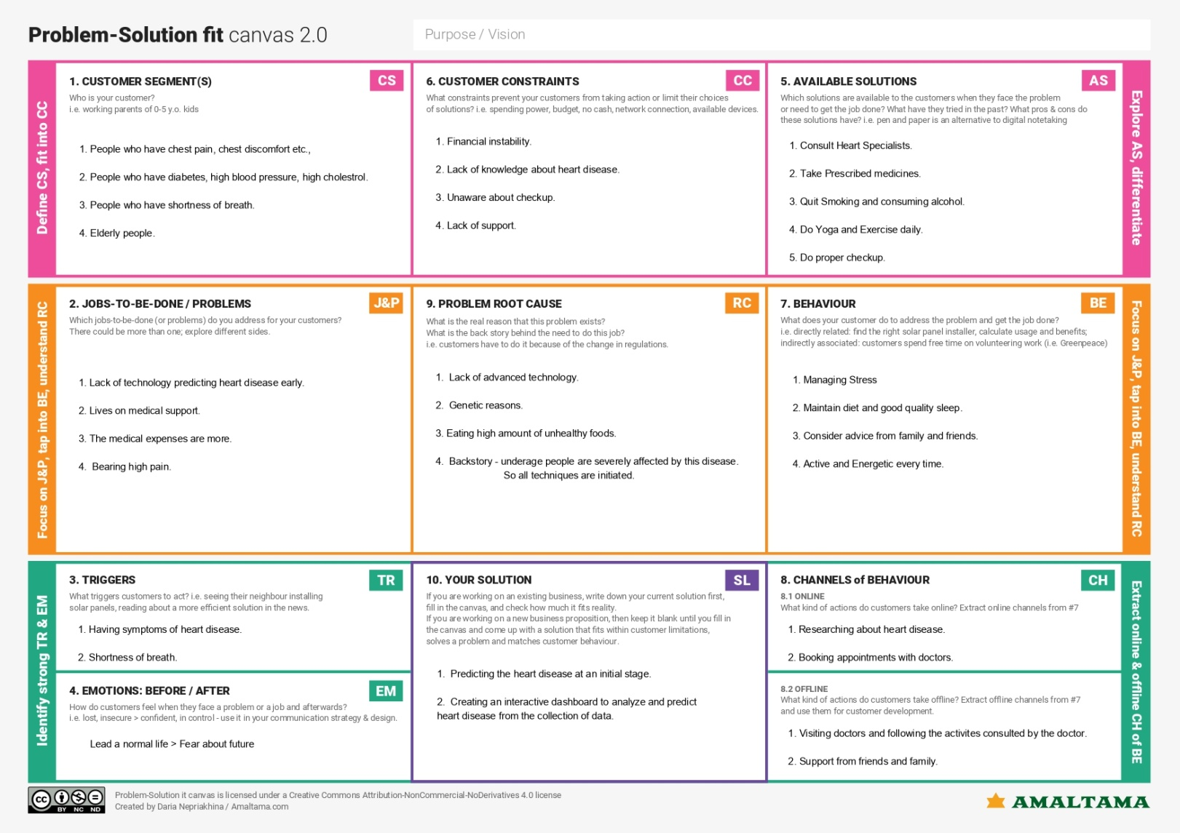

**Requirement Analysis:**

**Functional Requirements and Non - Functional Requirements :**

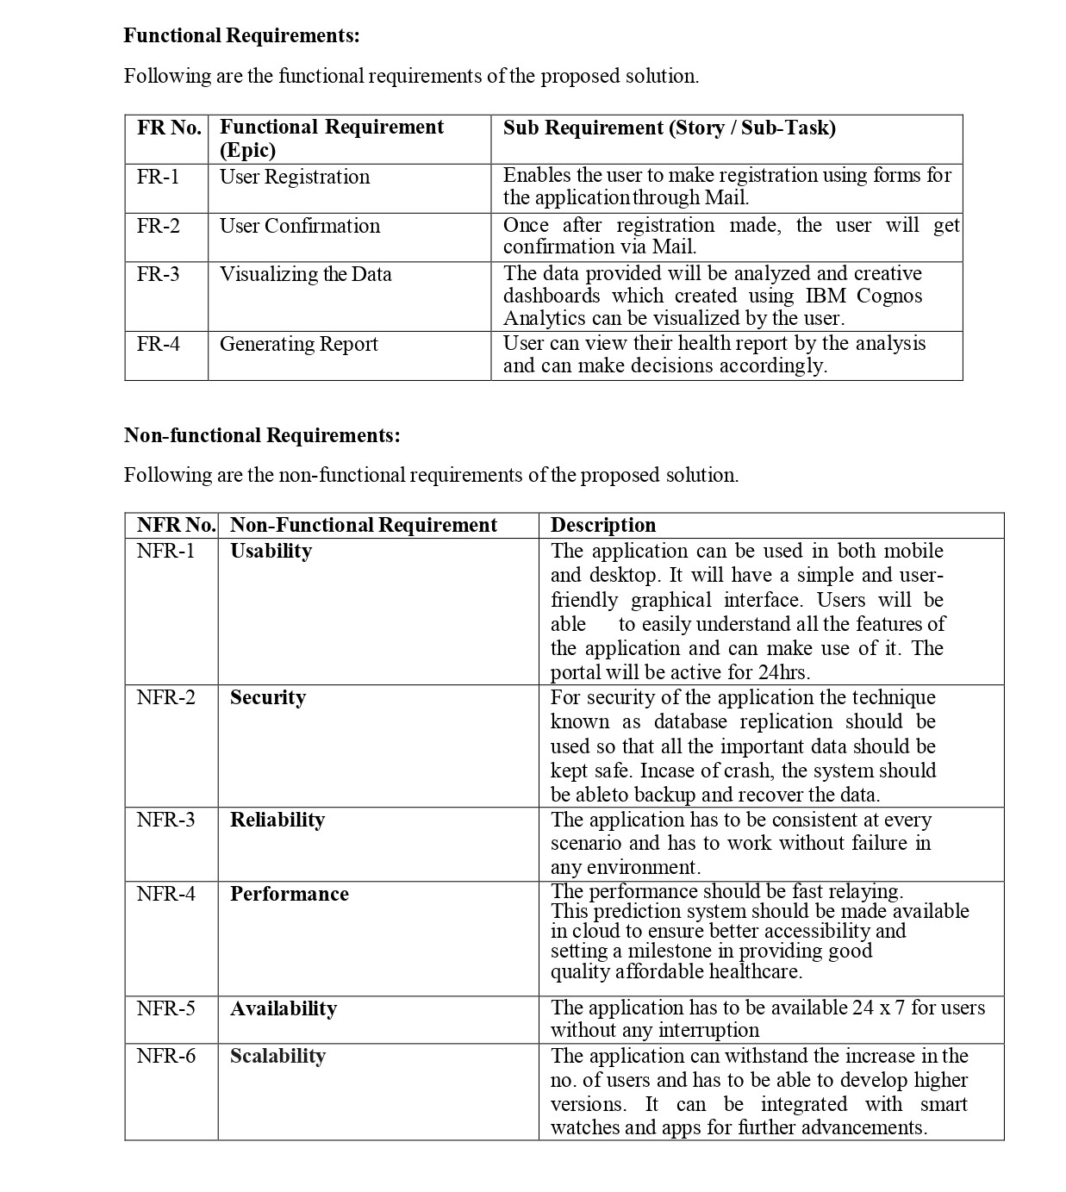

**Project Design:**

**Data Flow Diagram and User Stories:**

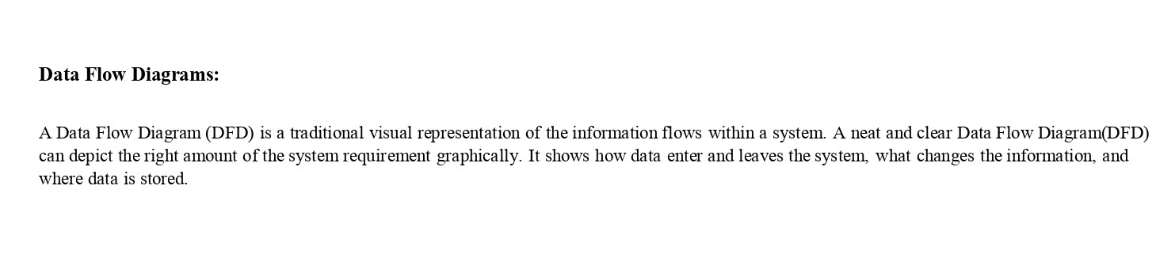

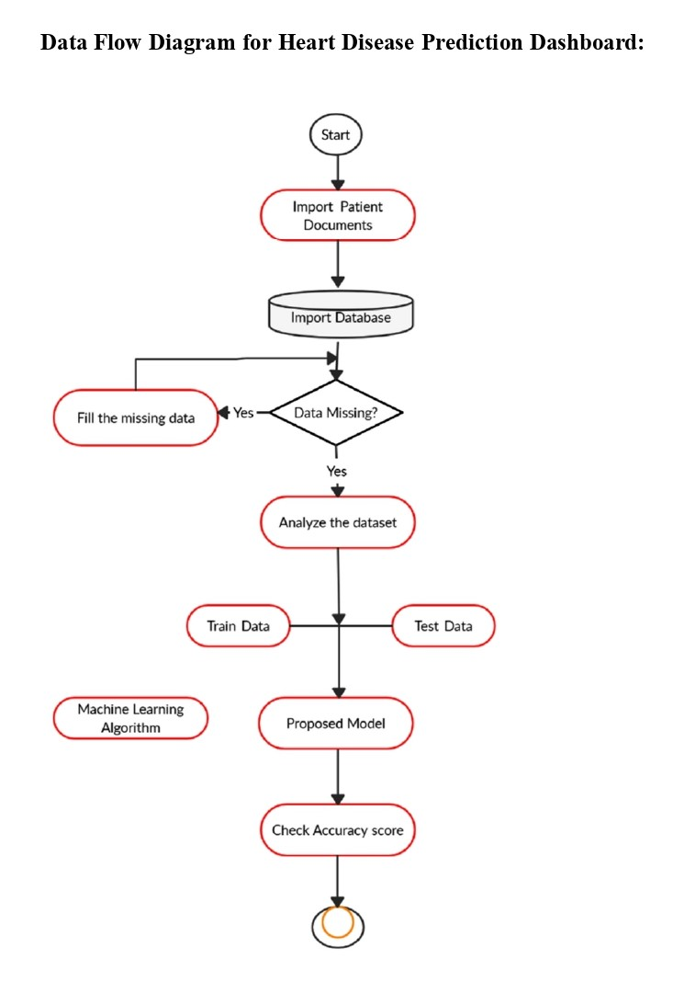

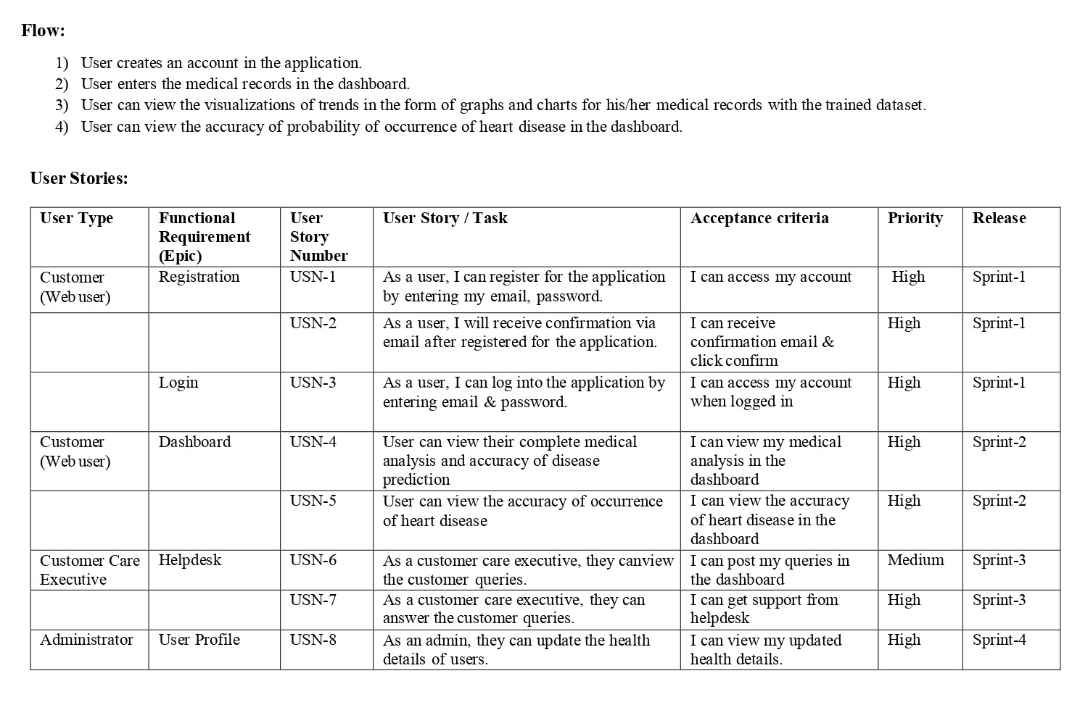

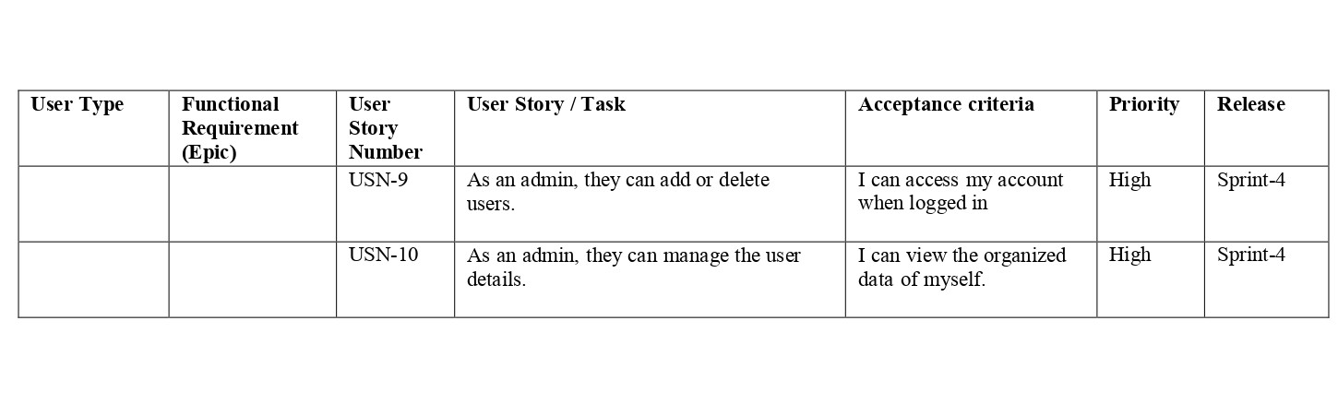

**Technical Architecture:**

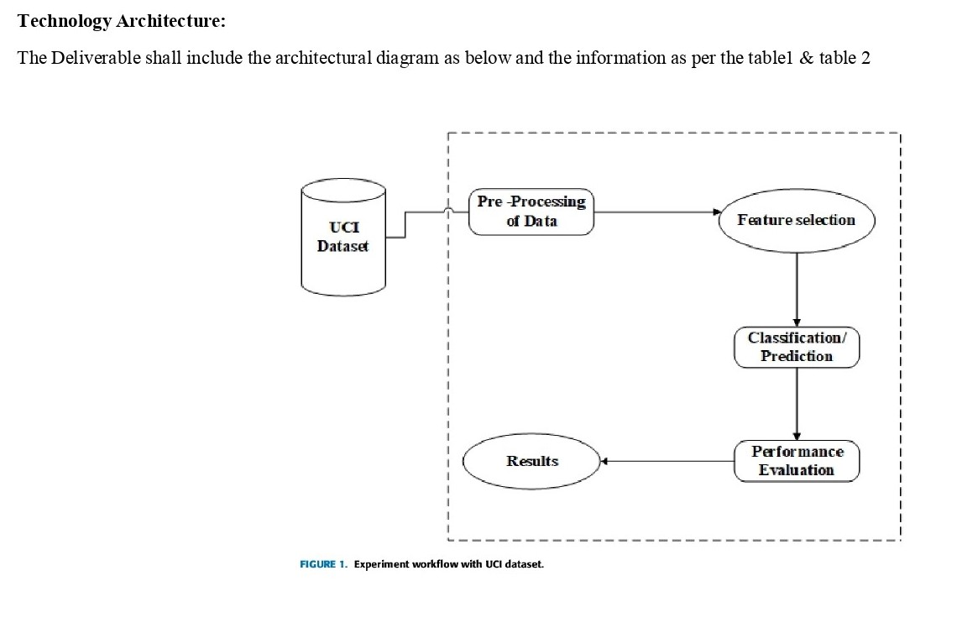

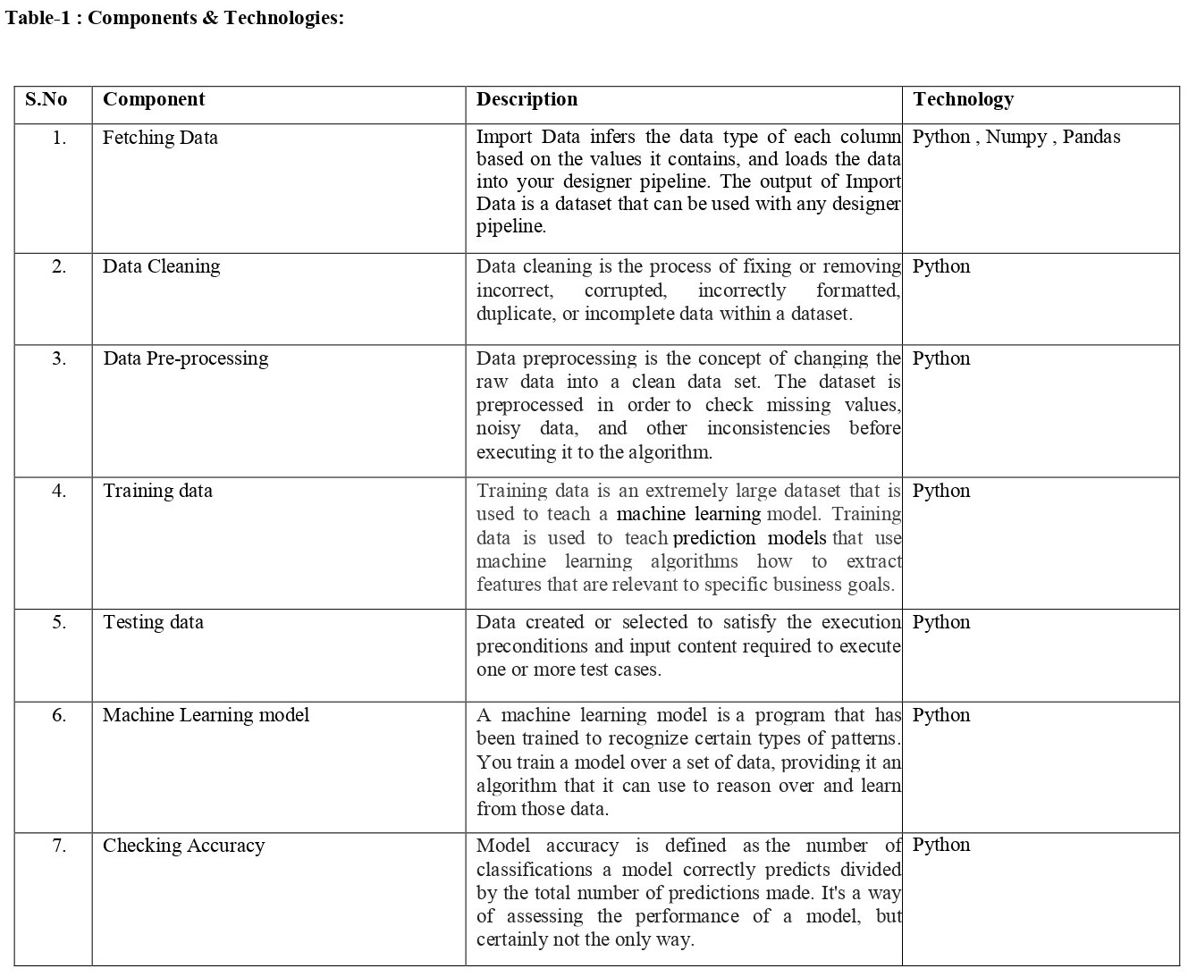

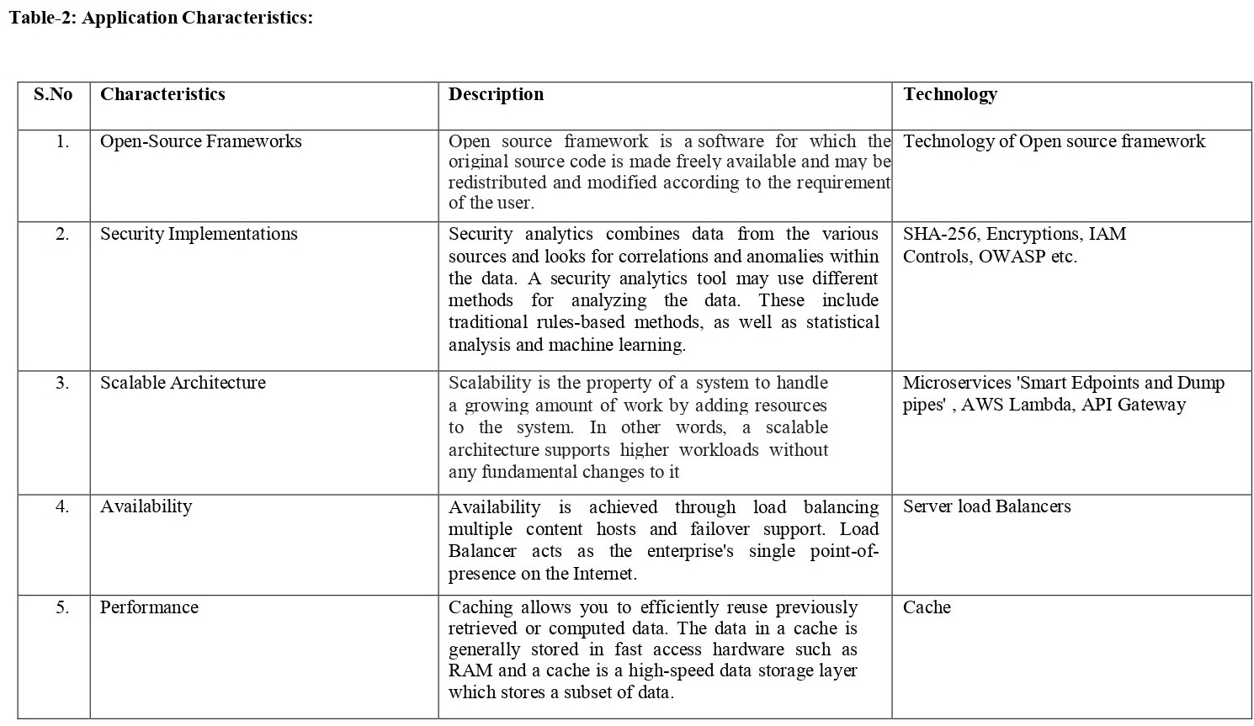

**Project Planning & Scheduling:**

**Sprint Planning and Estimation:**

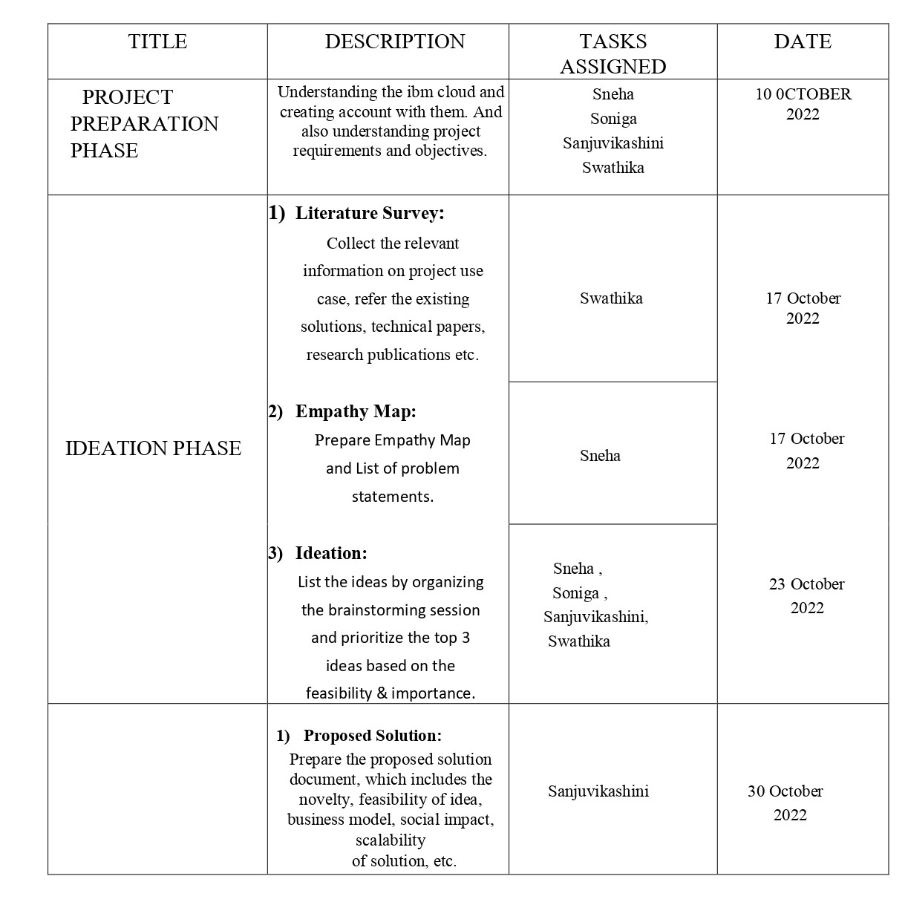

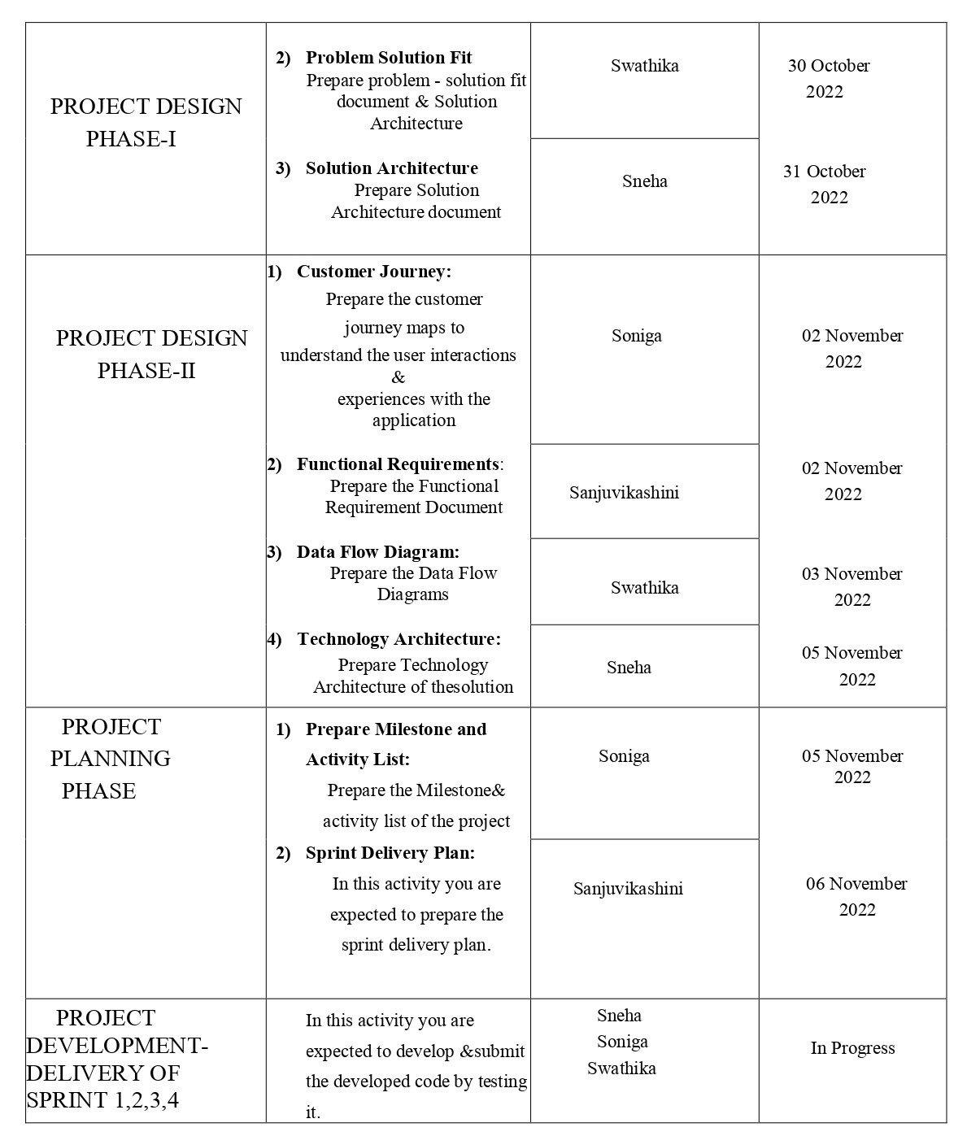

**Sprint Delivery Planning:**

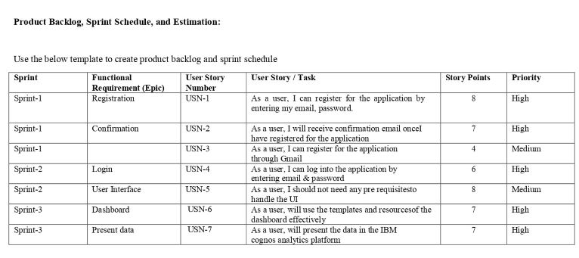

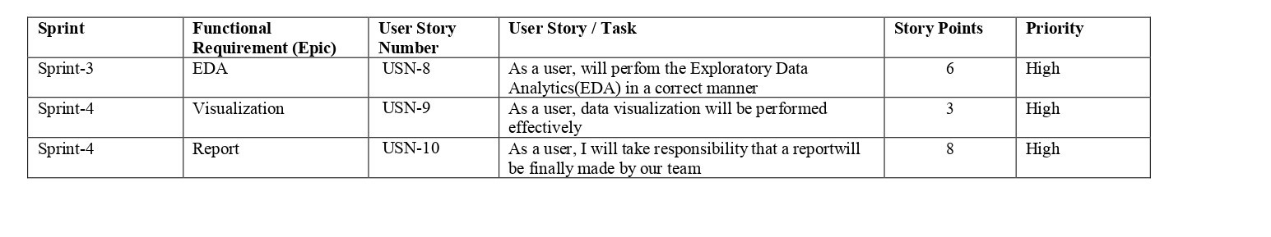

**Reports from JIRA:**

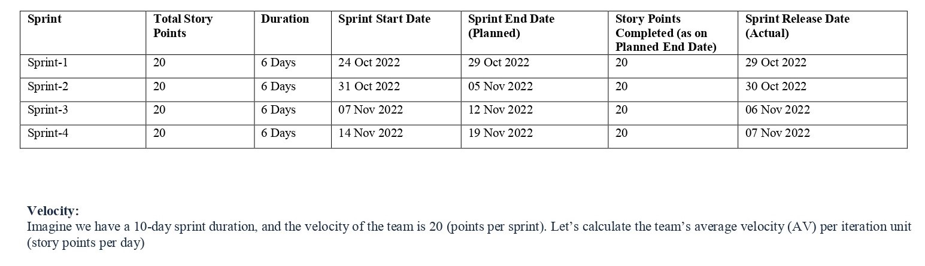

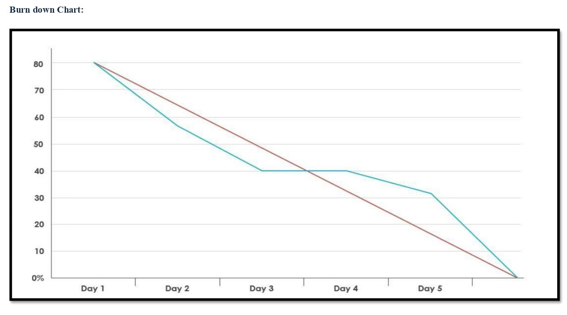

**Coding:**

**Code:**

<html>

<head>

<!-- Bootstrap CSS -->

<link rel="stylesheet" href="https://stackpath.bootstrapcdn.com/bootstrap/4.5.2/css/bootstrap.min.css" integrity="sha384-JcKb8q3iqJ61gNV9KGb8thSsNjpSL0n8PARn9HuZOnIxN0hoP+VmmDGMN5t9UJ0Z" crossorigin="anonymous">

<script src="https://code.jquery.com/jquery-3.5.1.slim.min.js" integrity="sha384-DfXdz2htPH0lsSSs5nCTpuj/zy4C+OGpamoFVy38MVBnE+IbbVYUew+OrCXaRkfj" crossorigin="anonymous"></script>

<script src="https://cdn.jsdelivr.net/npm/popper.js@1.16.1/dist/umd/popper.min.js" integrity="sha384-9/reFTGAW83EW2RDu2S0VKaIzap3H66lZH81PoYlFhbGU+6BZp6G7niu735Sk7lN" crossorigin="anonymous"></script>

<script src="https://stackpath.bootstrapcdn.com/bootstrap/4.5.2/js/bootstrap.min.js" integrity="sha384-B4gt1jrGC7Jh4AgTPSdUtOBvfO8shuf57BaghqFfPlYxofvL8/KUEfYiJOMMV+rV" crossorigin="anonymous"></script>

<title>Heart Disease Test</title>

</head>

<body >

<!-- Java Script -->

<script src="https://code.jquery.com/jquery-3.5.1.slim.min.js" integrity="sha384-DfXdz2htPH0lsSSs5nCTpuj/zy4C+OGpamoFVy38MVBnE+IbbVYUew+OrCXaRkfj" crossorigin="anonymous"></script>

<script src="https://cdn.jsdelivr.net/npm/popper.js@1.16.1/dist/umd/popper.min.js" integrity="sha384-9/reFTGAW83EW2RDu2S0VKaIzap3H66lZH81PoYlFhbGU+6BZp6G7niu735Sk7lN" crossorigin="anonymous"></script>

<script src="https://stackpath.bootstrapcdn.com/bootstrap/4.5.2/js/bootstrap.min.js" integrity="sha384-B4gt1jrGC7Jh4AgTPSdUtOBvfO8shuf57BaghqFfPlYxofvL8/KUEfYiJOMMV+rV" crossorigin="anonymous"></script>

<!-- Navbar-->

<nav class="navbar navbar-dark" style="background-color: rgb(13, 102, 87);">

<span class="navbar-brand mb-0 h1">Heart Disease Prediction</span>

</nav>

<div class="container">

<br>

<!--Form-->

<form action = "details.html" method ="POST" >

<fieldset>

<legend style="color: rgb(134, 67, 15);"><b>Beat the heart disease & feel the healthy beat</b></legend><br>

<div class="card card-body" style="background-color: rgba(13, 74, 115, 0.344);">

<div class="form-group row">

\<div class="col-sm-3">

<label for="age">Age</label>

<input type="number" class="form-control" id="age" name="age" required>

</div>

<div class="col-sm-3">

<label for="sex">Sex</label>

<select class="form-control" id="sex" name="sex" required>

<option disabled selected value> -- Select an Option -- </option>

<option value = "0">Female</option>

<option value = "1">Male</option>

</select>

</div>

</div>

<br>

<div class="form-group row">

<div class="col-sm">

<label for="cp">Chest Pain Type</label>

<select class="form-control" id="cp" name = "cp" required>

<option disabled selected value> -- Select an Option -- </option>

<option value = "1">Typical Angina</option>

<option value = "2">Atypical Angina</option>

<option value = "3">Non-anginal Pain</option>

<option value = "4">Asymptomatic</option>

</select>

</div>

<div class="col-sm">

<label for="trestbps">Resting Blood Pressure in mm Hg</label>

<input type="number" class="form-control" id="trestbps" name="trestbps" required>

</div>

<div class="col-sm">

<label for="chol">Serum Cholestoral in mg/dl</label>

<input type="number" class="form-control" id="chol" name="chol" required>

</div>

<div class="col-sm">

<label for="fbs">Fasting Blood Sugar > 120 mg/dl</label>

<select class="form-control" id="fbs" name="fbs" required>

<option disabled selected value> -- Select an Option -- </option>

<option value = "0">False</option>

<option value = "1">True</option>

</select>

</div>

<br>

<div class="form-group row">

<div class="col-sm">

<label for="restecg">Resting ECG Results </label>

<select class="form-control" id="restecg" name="restecg" required>

<option disabled selected value> -- Select an Option -- </option>

<option value = "0">Normal </option>

<option value = "1">Having ST-T wave abnormality </option>

<option value = "2">Probable or definite left ventricular hypertrophy</option>

</select>

</div>

<div class="col-sm">

<label for="thalach">Maximum Heart Rate</label>

<input type="number" class="form-control" id="thalach" name="thalach" required>

</div>

<div class="col-sm">

<label for="exang">Exercise Induced Angina </label>

<select class="form-control" id="exang" name="exang" required>

<option disabled selected value> -- Select an Option -- </option>

<option value = "0">No</option>

<option value = "1">Yes</option>

</select>

</div>

<div class="col-sm">

<label for="oldpeak">ST Depression Induced</label>

<input type="number" step="any" class="form-control" id="oldpeak" name="oldpeak" required>

</div>

</div>

<br>

<div class="form-group row">

<div class="col-sm">

<label for="slope">Slope of the Peak Exercise ST Segment </label>

<select class="form-control" id="slope" name="slope" required>

<option disabled selected value> -- Select an Option -- </option>

<option value = "1">Upsloping</option>

<option value = "2">Flat</option>

<option value = "3">Downsloping</option>

</select>

</div>

<div class="col-sm">

<label for="ca">Number of Vessels Colored by Flourosopy</label>

<select class="form-control" id="ca" name = "ca" required>

<option disabled selected value> -- Select an Option -- </option>

<option value = "0">0</option>

<option value = "1">1</option>

<option value = "2">2</option>

<option value = "3">3</option>

</select>

</div>

<div class="col-sm">

<label for="thal">Thalassemia</label>

<select class="form-control" id="thal" name = "thal" required>

<option disabled selected value> -- Select an Option -- </option>

<option value = "3">Normal</option>

<option value = "6">Fixed defect</option>

<option value = "7">Reversable defect</option>

</select>

</div>

</div>

<br>

<div class="form-group">

<input class="btn btn-primary" type="submit" value="Predict">

</div>

<!--Prediction Result-->

<div id ="result">

<strong style="color:red">{{result}}</strong>

</div>

</div>

</fieldset>

</form>

</div>

</body>

</html>

**Testing:**

**Test Cases:**

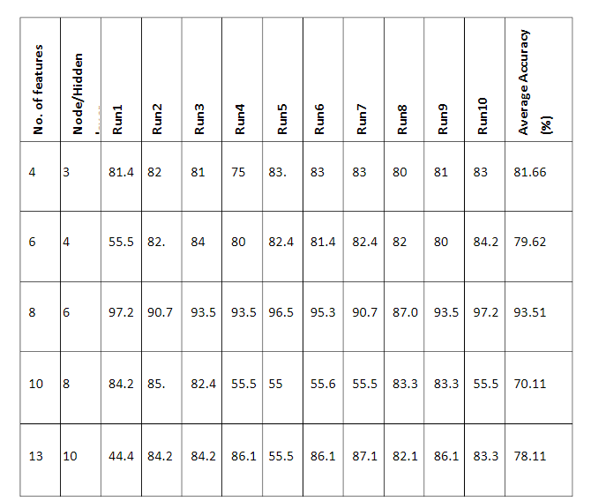

**User Acceptance Testing:**

# Purpose of Document:

The purpose of this document is to briefly explain the test coverage and open issues of the Global sales data analytics project at the time of the release to User Acceptance Testing (UAT).

# Defect Analysis:

This report shows the number of resolved or closed bugs at each severity level, and how they were resolved

|  |  |  |  |  |  |
| --- | --- | --- | --- | --- | --- |
| **Resolution** | **Severity 1** | **Severity 2** | **Severity 3** | **Severity 4** | **Subtotal** |
| By Design | 5 | 2 | 2 | 0 | 9 |
| Duplicate | 1 | 0 | 5 | 0 | 6 |
| External | 2 | 3 | 0 | 1 | 6 |
| Fixed | 11 | 2 | 4 | 10 | 27 |
| Not Reproduced | 0 | 0 | 1 | 0 | 1 |
| Skipped | 0 | 0 | 1 | 1 | 2 |
| Won't Fix | 0 | 5 | 2 | 1 | 8 |
| Totals | 19 | 12 | 15 | 13 | 59 |

# Test Case Analysis:

This report shows the number of test cases that have passed, failed, and untested

|  |  |  |  |  |  |  |  |  |
| --- | --- | --- | --- | --- | --- | --- | --- | --- |
| **Html page creation** | | **Total Cases** | | **Not Tested** | | **Fail** | | **Pass** |
| Print Engine | | 7 | | 0 | | 0 | | 7 |
| Data wrangling | | 20 | | 0 | | 3 | | 17 |
| Create dashboard | | 2 | | 0 | | 0 | | 2 |
| Create story | | 3 | | 0 | | 0 | | 3 |
| Create report | 9 | | 0 | | 0 | | 9 | |
| Final Report Output | 4 | | 0 | | 0 | | 4 | |
| Embedded page | 2 | | 0 | | 0 | | 2 | |

**Results:**

**Phase Performance Metrics:**

Performance metrics:

|  |  |  |
| --- | --- | --- |
| **S.No.** | **Parameter** | **Values** |
| 1. | Dashboard design | 14 |
| 2. | Data Responsiveness | 14/16 AND RPS 4.2 |
| 3. | Amount Data to Rendered (DB2 Metrics) | 1206/1206 and Hit ration is 100% |
| 4. | Utilization of Data Filters | 100 |
| 5. | Effective User Story | 12 |
| 6. | Descriptive Reports | 12 |

**Advantages & Disadvantages:**

**Advantages:**

* Helps to identify the issue.
* Helps to treat with correct medicines.
* Helps to give required and correct treatment.
* Provides proper necessary details for the doctors for further treatments.

**Disadvantages:**

* Lack of analysis.
* Lack of commitment and patience.
* Low quality of data.
* Privacy concerns.
* Complexity & Bias.

**Conclusion:**

The early prognosis of cardiovascular diseases can aid in making decisions on lifestyle changes in high risk patients and in turn reduce the complications, which can be a great milestone in the field of medicine. This project resolved the feature selection i.e. backward elimination and RFECV behind the models and successfully predict the heart disease, with 85% accuracy. The model used was Logistic Regression. Further for its enhancement, we can train on models and predict the types of cardiovascular diseases providing recommendations to the users, and also use more enhanced models. A cardiovascular disease detection model has been developed using three ML classification modelling techniques. This project predicts people with cardiovascular disease by extracting the patient medical history that leads to a fatal heart disease from a dataset that includes patients’ medical history such as chest pain, sugar level, blood pressure, etc. This Heart Disease detection system assists a patient based on his/her clinical information of them been diagnosed with a previous heart disease. The algorithms used in building the given model are Logistic regression, Random Forest Classifier and KNN [22]. The accuracy of our model is 87.5%. Use of more training data ensures the higher chances of the model to accurately predict whether the given person has a heart disease or not [9]. By using these, computer aided techniques we can predict the patient fast and better and the cost can be reduced very much. There are a number of medical databases that we can work on as these Machine learning techniques are better and they can predict better than a human being which helps the patient as well as the doctors. Therefore, in conclusion this project helps us predict the patients who are diagnosed with heart diseases by cleaning the dataset and applying logistic regression and KNN to get an accuracy of an average of 87.5% on our model which is better than the previous models having an accuracy of 85%. Also, it is concluded that accuracy of KNN is highest between the three algorithms that we have used i.e. 88.52%. ‘Figure 6’ shows 44% of people that are listed in the dataset are suffering from Heart Disease.

**Future Scope:**

* Future enhance of the Heart Disease Prediction System is to predict a specific Heart Disease type such Heart attracts, CVD, CAD, etc.
* The potential of the Heart Disease Prediction System in a different area are hospital, Clinic, smartphone, smart wear, hospital/police emergency system and integrate with fitness mobile application.
* We can integrate this model in hospital and clinic system to predict heart disease.
* We will implement this Heart Disease Prediction Model into smart wears to detect essential attributes of Heart Disease and suggest to the precaution of Heart Disease.
* We can also apply this model into a mobile app to easily test ourselves Heart Disease.
* We can integrate smart wear to the hospital and police emergency system to save the life of the patient at the emergency condition.

**Appendix:**

**Project Demo:**

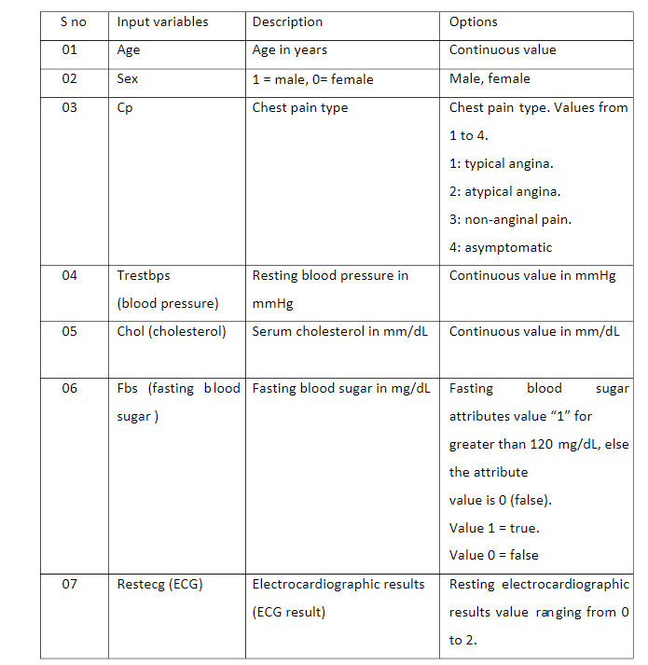

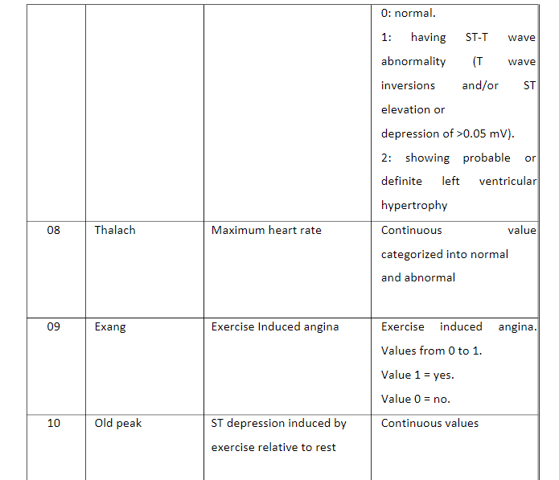

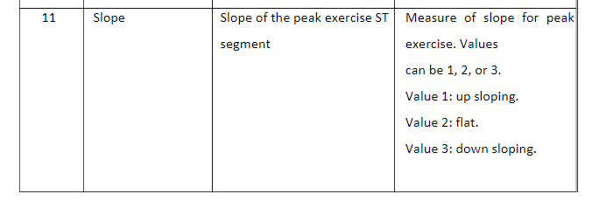

S no

Input variables

Description

Options

01

Age

Age in years

Continuous value

02

Sex

1 = male, 0= female

Male, female

03

Cp

Chest pain type

Chest pain type. Values from

1 to 4.

1: typical angina.

2: atypical angina.

3: non-anginal pain.

4: asymptomatic

04

Trestbps

(blood pressure)

Resting blood pressure in

mmHg

Continuous value in mmHg

05

Chol (cholesterol)

Serum cholesterol in mm/dL

Continuous value in mm/dL

06

Fbs (fasting blood

sugar )

Fasting blood sugar in mg/dL

Fasting blood sugar

attributes value “1” for

greater than 120 mg/dL, else

the attribute

value is 0 (false).

Value 1 = true.

Value 0 = false

07

Restecg (ECG)

Electrocardiographic results

(ECG result)

Resting electrocardiographic

results value ranging from 0

to 2

S no

Input variables

Description

Options

01

Age

Age in years

Continuous value

02

Sex

1 = male, 0= female

Male, female

03

Cp

Chest pain type

Chest pain type. Values from

1 to 4.

1: typical angina.

2: atypical angina.

3: non-anginal pain.

4: asymptomatic

04

Trestbps

(blood pressure)

Resting blood pressure in

mmHg

Continuous value in mmHg

05

Chol (cholesterol)

Serum cholesterol in mm/dL

Continuous value in mm/dL

06

Fbs (fasting blood

sugar )

Fasting blood sugar in mg/dL

Fasting blood sugar

attributes value “1” for

greater than 120 mg/dL, else

the attribute

value is 0 (false).

Value 1 = true.

Value 0 = false

07

Restecg (ECG)

Electrocardiographic results

(ECG result)

Resting electrocardiographic

results value ranging from 0

to 2

S no

Input variables

Description

Options

01

Age

Age in years

Continuous value

02

Sex

1 = male, 0= female

Male, female

03

Cp

Chest pain type

Chest pain type. Values from

1 to 4.

1: typical angina.

2: atypical angina.

3: non-anginal pain.

4: asymptomatic

04

Trestbps

(blood pressure)

Resting blood pressure in

mmHg

Continuous value in mmHg

05

Chol (cholesterol)

Serum cholesterol in mm/dL

Continuous value in mm/dL

06

Fbs (fasting blood

sugar )

Fasting blood sugar in mg/dL

Fasting blood sugar

attributes value “1” for

greater than 120 mg/dL, else

the attribute

value is 0 (false).

Value 1 = true.

Value 0 = false

07

Restecg (ECG)

Electrocardiographic results

(ECG result)

Resting electrocardiographic

results value ranging from 0

to 2

S no

Input variables

Description

Options

01

Age

Age in years

Continuous value

02

Sex

1 = male, 0= female

Male, female

03

Cp

Chest pain type

Chest pain type. Values from

1 to 4.

1: typical angina.

2: atypical angina.

3: non-anginal pain.

4: asymptomatic

04

Trestbps

(blood pressure)

Resting blood pressure in

mmHg

Continuous value in mmHg

05

Chol (cholesterol)

Serum cholesterol in mm/dL

Continuous value in mm/dL

06

Fbs (fasting blood

sugar )

Fasting blood sugar in mg/dL

Fasting blood sugar

attributes value “1” for

greater than 120 mg/dL, else

the attribute

value is 0 (false).

Value 1 = true.

Value 0 = false

07

Restecg (ECG)

Electrocardiographic results

(ECG result)

Resting electrocardiographic

results value ranging from 0

to 2

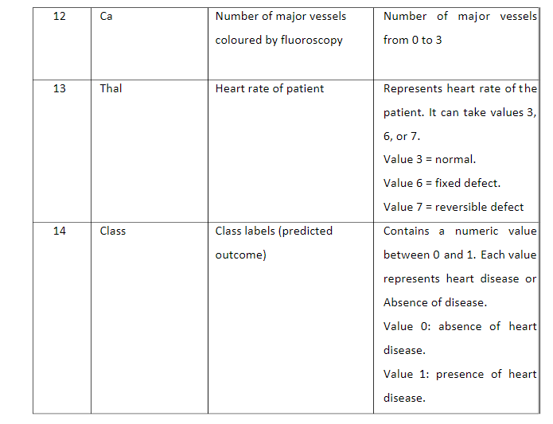

**Project Demo Link:**

<https://vimeo.com/776031933>

**GitHub Link:**

https://github.com/IBM-EPBL/IBM-Project-8255-1658913112

**THANK**  **YOU**